*To obtain full marks for assignment work,you must upload your assignment to Moodle (no later than submission date and time given)* ***AND*** *ensure you are in class to demonstrate your work on given date.*

*Penalties will apply for late submissions (see Moodle)*

YOU MUST ENSURE THAT THE WORK YOU SUBMIT FOR CA PURPOSES IS ENTIRELY YOUR OWN WORK.

**Lab 2 – Shape Up Project**

**Task 1**

In this exercise, you’ll enhance the home page you worked on in Lab1 so it includes a two-tier horizontal navigation menu and an image link. You’ll also format the list in the sidebar so the items aren’t indented, and you’ll remove the underlines from the links. When you’re through, the home page should look similar to this:

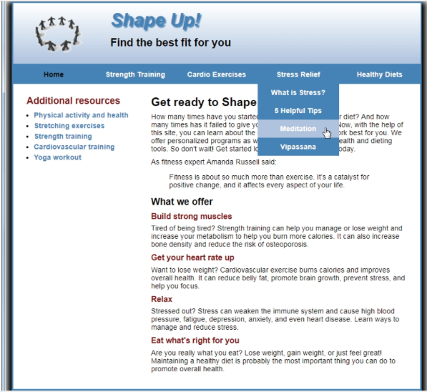

1. Add a 2-tier navigation menu. The main menu and Stress Relief submenu should include the links shown above. In addition, a Healthy Diets submenu should be included with the links “Why a Healthy Diet?”, “Plan Your Meals”, “Count Your Calories”, and “Calculate Your BMI”. Be sure all the links refer to the correct pages. (The “What is Stress?” link should refer to the index.html page in the stress folder, and the “Why a Healthy Diet?” link should refer to the index.html page in the diet folder).
2. Format the navigation menu so the background color is steelblue, so the link for the page that’s currently displayed (in this case, Home) has black text, and so the link that the mouse is hovering over or has the focus (in this case, Meditation) has a lightsteelblue background.
3. Remove the links from the h3 headings in the section, since these pages can now be accessed from the menu.
4. Modify the logo in the header so it’s a link that displays the home page. • Format the list in the sidebar so there’s no space to the left of the list items. In addition, remove the underlines from the links in the list items.

**Task 2**

In this exercise, you’ll enhance the home page you worked on in Task 1 so that it uses Responsive Web Design.

1. Make a copy of the main.css style sheet and name it main_rwd.css. Then, modify the HTML for the page so it uses this style sheet.
2. Modify the page so it uses a fluid layout. The maximum width for the page should be 1024px, and the page should occupy 95% of the browser window. Be sure to make the left and right margins and padding as well as the structural elements fluid.
3. If you used pixels for any top or bottom margins or padding, convert them to ems. In addition, if you specified any of the font sizes using pixels, convert them to percentages or ems
4. Make the image in the header scalable. Make sure that the width of the image is limited to its native size of 140px, and make sure that the image can’t be reduced to a width less than 70px.

**Task 3**

**media query for a tablet in portrait orientation**

1. Add a meta element to the page to control the viewport for media queries.
2. Add a media query that will be applied to screens with a maximum width of 900px. Then, add styles to remove the shadow from the page and reduce the size of all the fonts on the page to 90%.

**media query for a mobile phone in landscape orientation**

1. Add a media query that will be applied to screens with a maximum width of 767px. Then, add the HTML and CSS required to hide the navigation menu and display a SlickNav menu in its place. You’ll find the slicknav.css file in the styles folder, you’ll find the slicknav.min.js file in the js folder, and you can get the jQuery library from the jQuery Content Delivery Network.
2. Change the background color of the SlickNav menu to steelblue, and change its padding to 3px.
3. Change the background color of the ul and <a> elements for the mobile menu to steelblue. In addition, when the mouse hovers over a link in the menu, the link should be displayed in lightsteelblue.
4. Change the font size of the first heading in the header to 200%, and format the page so it appears in one column. **Note:** The page shown above was captured on a desktop so it is an approximation.

**media query for a mobile phone in portrait orientation**

1. Add a media query that will be applied to screens with a maximum width of 479px. Then, reduce the font sizes of the headings in the header and the

elements in the section.   
  
  
Note: The page shown above was captured on a desktop so you can see the layout of the entire page